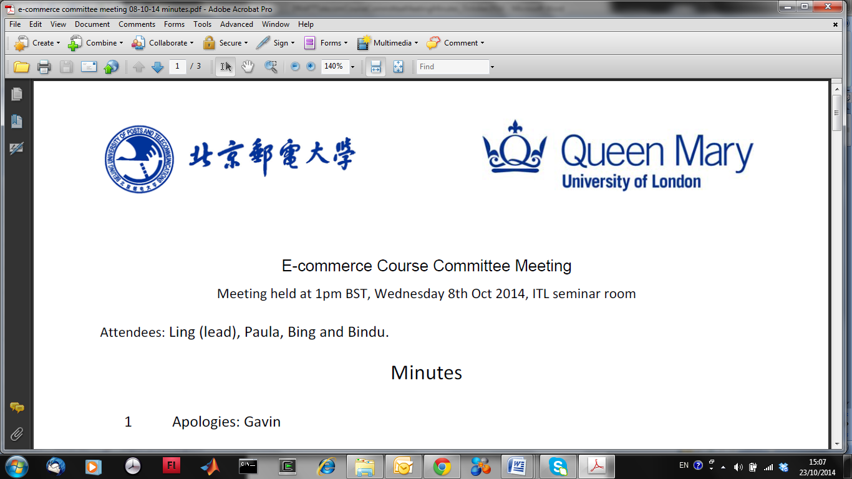

**EBU5303 Multimedia Fundamentals**

# Worksheet 1: Digitisation, Colour, Images

## Question 1. Do you remember?

1. What is Fourier analysis used for?
2. Define aliasing.
3. What is shown in the Spectral Power Distribution (SPD) of a light?
4. Define a colour’s hue, brightness, and saturation.
5. What is the colour depth of a true colour image?
6. Define image resolution.

## Question 2. Do you understand?

1. Explain how the digitisation parameters (sampling rate and colour depth) affect the size of a digital image file.
2. Explain how aliasing can be avoided when digitising a sound signal.
3. In the (R, G, B) model, explain how you can increase the brightness of a colour.
4. In the (C, M, Y) model, explain how you can decrease the saturation of a colour.
5. What are the advantages of a vector-based image over a bitmap? Are there any disadvantages?
6. What happens to the resolution of an image if you display it at a size larger than intended? Explain your answer.

## Question 3. Can you apply your knowledge?

1. You are digitising a signal and you decide to use 5 bits per sample.
   1. How many different values can the signal take?
   2. Calculate an approximation of the SQNR of the signal.
2. Calculate the size of a video file, in bytes, which has the following characteristics: the pixel dimension is 200 pixels x 300 pixels, each pixel is encoding using 24 bits (true colour format), the frame rate is 24 frames/s, the audio track contains speech digitised at 15 kHz and 8 bits/sample, the duration is 1 minute.
3. What (R, G, B) values would you use to encode an unsaturated bright blue colour?
4. What (H, S, V) values would you use to encode a bright orange colour? Estimate these values from the top of your head, then verify in the colour converter.
5. Calculate the size of an image in Kbyte (kilobyte) knowing the following parameters: true colour, pixel dimension = 300 x 400.
6. How can you reduce the size of a true colour image to just a 1/3 of its original size by changing its colour depth? Give several solutions.

## Question 4. Can you analyse and/or evaluate?

1. You have a digital image in 8-bit colour which appears blurred. Is this a matter of aliasing or quantisation error? Justify your answer.
2. In your opinion, what are the possible implications of choosing a sampling rate that is higher than the Nyquist rate?
3. Cyan ink is spread onto a white sheet of paper. What colour will you see if the paper is illuminated with a magenta light? Justify your answer.
4. Do you think colours can carry meaning?
5. Does conversion from true colour to index-based format always incur some perceived quality loss?
6. In your opinion, are grayscale images as good as colour images?

## Question 5. Can you create?

1. Write a simple MATLAB program that can read an audio file data and output its digitisation parameters (sample size and bit depth).
2. Devise a simple pseudo algorithm to improve the appearance of an under sampled image.
3. Write a simple MATLAB program that can read an image file data and output its digitisation parameters (sample size and colour depth).
4. Devise a simple pseudo algorithm to transform an RGB image into YCbCr.
5. Write a simple MATLAB program that can convert an image from grayscale to binary.
6. Devise a simple pseudo algorithm to convert a true colour image into an index-based image.